EXPT NO:6 | INTEGRATE DATA FROM VARIOUS SOURCES FOR COMPREHENSIVE ANALYSIS USING TABLEAU AND POWERBI
DATE: 24.07.2026

PRE-LAB QUESTIONS (PROVIDE BRIEF ANSWERS TO THE FOLLOWING QUESTIONS)
- What is data integration in the context of Business Intelligence (BI)?

Data integration is the process of combining data that lives in different, heterogeneous sources (files, databases, applications) into a single, consistent view. In BI, it means bringing together separately-collected datasets , like a sales export and a targets spreadsheet , so they can be queried, modeled, and visualized together instead of being analyzed in isolation.

- Explain the difference between a join and a data blend in Tableau.

A join combines two tables row-by-row at the source/query level, usually within the same connection, before any aggregation happens , it produces one wide table and works best when both tables share the same granularity. A blend keeps each data source separate and combines them only at the aggregate (summary) level, matching on a common dimension after each source has already been summarized. Blending is used when tables can't be joined directly, such as when they come from different connections or have mismatched granularity.

- What are relationships and cardinality (e.g., one-to-many, many-to-many) in Power BI's data model?

A relationship links two tables in the data model through a common column without physically merging their rows, so each table keeps its own grain while still being filterable together. Cardinality describes how rows on each side of that link correspond: one-to-many (one row in Table A matches many rows in Table B , the most common case), many-to-one (the reverse), one-to-one (each row matches exactly one row on the other side), and many-to-many (rows can repeat on both sides, which needs careful handling to avoid ambiguous results).

- Why is data quality (e.g., consistent naming conventions, data types) crucial when integrating data from different sources?
Joins and relationships match rows based on exact key values, so inconsistent naming ("N. America" vs "North America") causes rows to fail to match, producing orphaned records, duplicated categories, or silently incomplete totals. Correct data types matter equally , a numeric field stored as text won't sum, and a date stored as text won't build a proper date hierarchy or sort correctly. Poor data quality doesn't usually throw an error; it quietly produces wrong KPIs, which is more dangerous than a visible failure.

- Name two common challenges encountered during data integration.

(1) Inconsistent or mismatched key values across sources , different spellings, abbreviations, casing, or trailing spaces in a shared field like Region, which breaks joins/relationships until standardized. (2) Mismatched granularity between sources , for example, transaction-level sales data versus a single yearly target per region , which requires aggregating one side before the two can be compared meaningfully.

IN-LAB EXERCISE:
OBJECTIVE:
To connect to, combine, and model data from multiple disparate sources in Tableau and Power BI to create a unified, comprehensive dashboard for holistic analysis.
GitHub Repo Link: https://github.com/j-abhishek26/24ADC001-24BAD002/tree/main/Experiment%206

PROCEDURE:
- Data Collection:
  - Import data from at least two different sources (e.g., a CSV file and an Excel file).
  - Dataset 1: Sales Data (CSV file) with fields like Order ID, Order Date, Region, Sales Amount.
  - Dataset 2: Regional Sales Targets (Excel file) with fields like Region, Sales Target, Target Year.
- Data Preparation and Transformation:
  - Clean both datasets: Check for inconsistencies in region names (e.g., "N. America" vs. "North America").
  - Ensure data types are correct (e.g., Sales Amount is numeric, Order Date is a date).
  - Handle any missing values as appropriate.
- Data Integration and Modeling:
  - Tableau: Use the Data Source pane to establish a relationship or join between the Sales Data and Regional Targets tables using the common Region field.
  - Power BI: Use the Model view to create a relationship between the two tables, connecting them on the Region column. Define the cardinality (e.g., many-to-one).
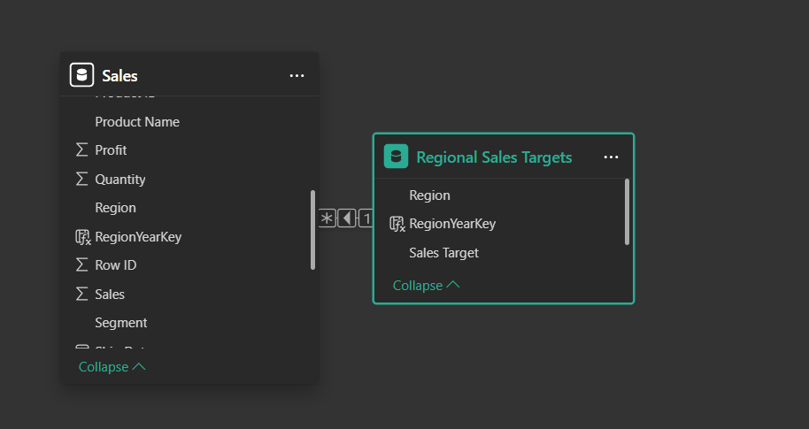
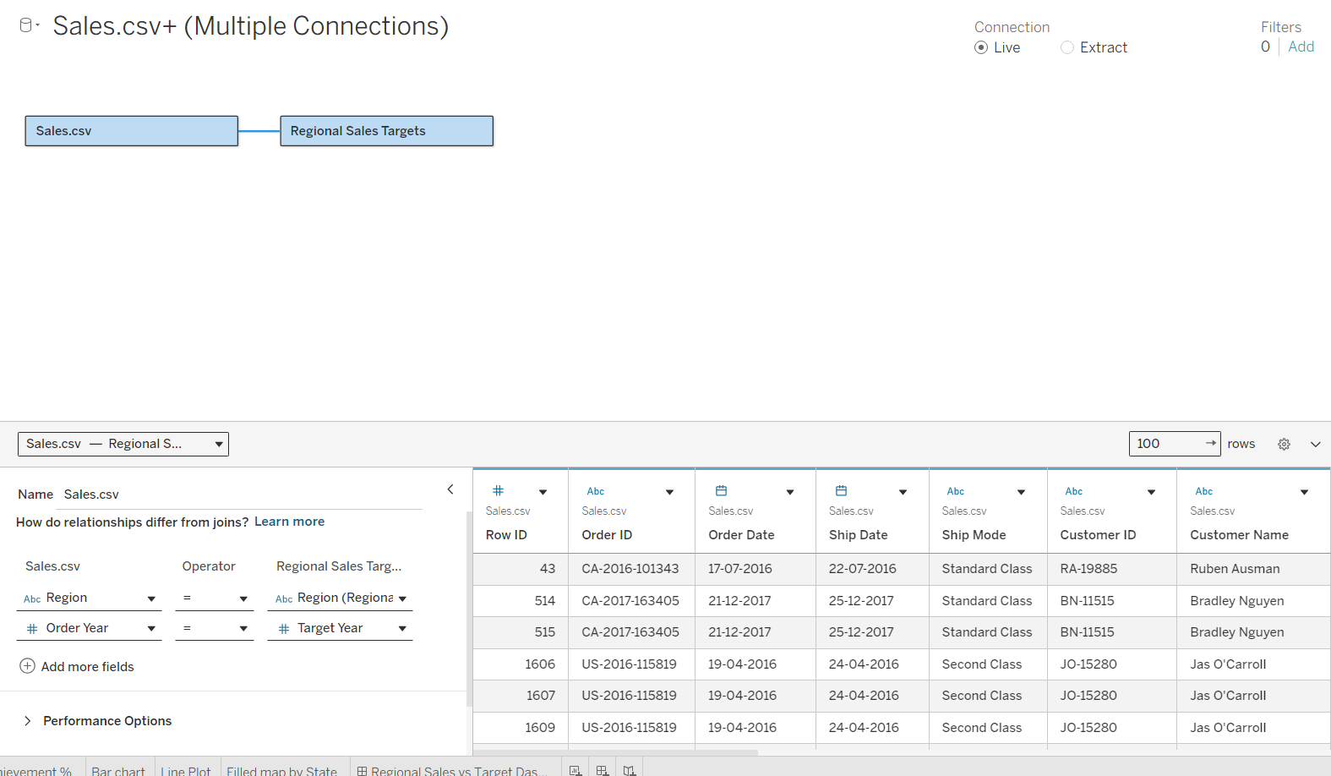

- Create Calculated Fields for Comparison:
  - Develop new measures that leverage both datasets.

  - Examples: Target Achievement % = (SUM(Sales) / SUM(Sales Target)) * 100
  - Sales vs. Target Variance = SUM(Sales) - SUM(Sales Target)
- Design a Comprehensive Dashboard:
  - Create visuals that combine data from both sources to provide a single view of performance.
  - Add KPI cards for Total Sales and Overall Target Achievement %.
  - Use a gauge chart or bullet chart to show sales performance against targets for each region.
  - Create a combined bar chart showing Actual Sales vs. Target Sales by Region.
  - Use a map to visualize the Sales vs. Target Variance, highlighting underperforming or overperforming regions.

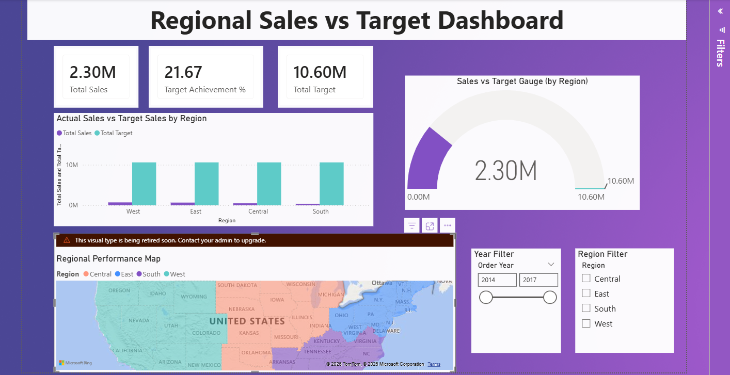
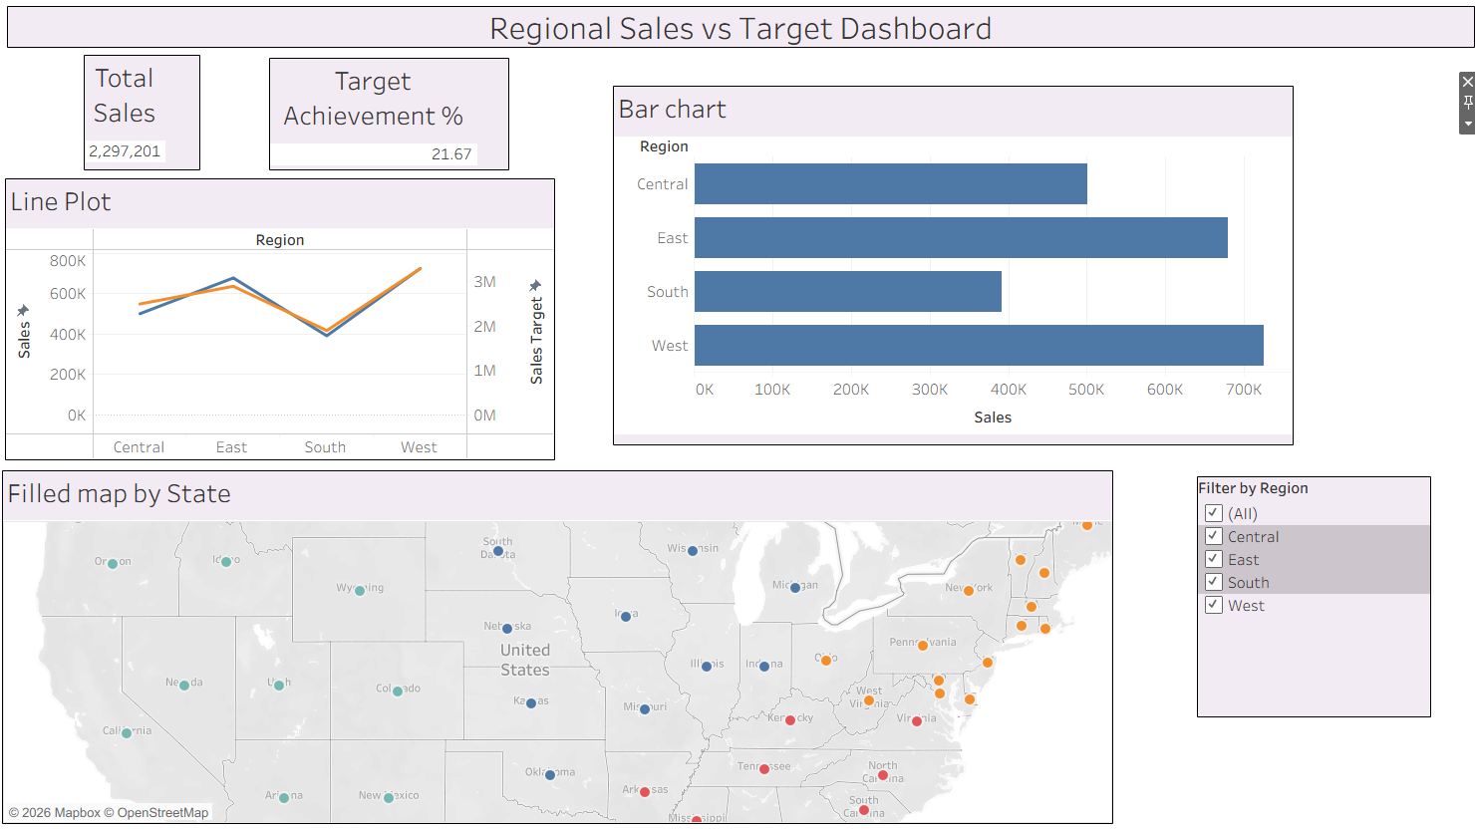
- Validate Data Integrity:
  - Verify that the joined/related data is accurate by cross-checking values.
  - Ensure filters on the dashboard correctly update visuals that use data from both sources.
- Publishing and Sharing:
  - Tableau: Publish the workbook to Tableau Public or Tableau Server.
  - Power BI: Publish the report to Power BI Service and share the link. Experiment Datasets:
Dataset 1: Retail Sales Data (CSV) Fields Used:
- Order ID – Unique identifier for each order
- Order Date – Date of the sales transaction
- Region – Sales region
- Sales – Sales revenue from the order
Dataset 2: Regional Sales Targets (Excel) Fields Used:
- Region – Sales region (used as the key for joining/relationship)
- Sales Target – The sales goal for the region
- Target Year – The year for which the target is set

POST-LAB QUESTIONS (PROVIDE BRIEF ANSWERS TO THE FOLLOWING QUESTIONS)

- How did integrating the sales targets data provide a more complete analytical picture than using the sales data alone?

Sales data alone only shows volume , it can't say whether a region is doing well or poorly. Adding the targets table gave a benchmark, turning raw sales figures into "performance versus goal." This is what surfaced which regions were actually over- or under-performing, an insight that simply isn't available from the transaction data by itself.

- Describe the type of join or relationship you used to combine the two datasets and explain why it was the appropriate choice.

A relationship (Power BI's Model-view relationship / Tableau's noodle-based relationship) on Region, with many-to-one cardinality, since many sales transactions map to a single target row per region. A relationship was preferable to a physical join because the two tables have different grains , transaction-level sales versus one row per region per year , a relationship preserves each table's native granularity and lets the tool aggregate Sales up to Region level automatically before comparing, rather than pre-collapsing the data.

- What challenges, if any, did you face regarding data granularity or mismatched keys (e.g., different region names) between the two sources?

The Region field had several inconsistent spellings in the raw sales file ("N. America", "N.America", "north america", "APAC" vs "Asia Pacific", trailing spaces on "Europe"), which meant those rows would not initially match the clean names in the targets file , they had to be standardized (via Find & Replace in Excel, or Grouping/Replace Values inside Tableau/Power BI) before the relationship linked every row correctly. Granularity was the second issue: sales data was at the individual-order level while targets were a single yearly figure per region, so every visual had to aggregate Sales with SUM() before it could be compared to the target.

- How can creating variance calculations (e.g., Sales vs. Target) help a business manager make better decisions?

A variance figure converts two separate numbers into one actionable signal , a manager can immediately see which regions are behind target and by how much, without mentally subtracting values themselves. This supports prioritizing resources or interventions toward underperforming regions, recognizing overperforming ones, and setting more realistic targets for the next period based on how far off actual results were from this year's goals.

- What other data source (e.g., marketing campaign data, customer demographics) could you integrate to further enrich this analysis, and what new insights might it provide?

Marketing campaign spend data (by region and month) could be integrated to calculate a rough ROI per region, revealing whether underperforming regions are under-invested or overperforming regions are simply outspending others. Customer demographic data could also be joined in to segment the variance by customer type or age group, showing not just which regions are behind target but which customer segments within them are driving that gap , a much more actionable insight than the region-level variance alone.

RESULT:
The retail sales and regional targets datasets were successfully connected, cleaned, and integrated in both Tableau and Power BI. By creating relationships between the sources, a unified data model was built. The resulting comprehensive dashboard visualized sales performance against set targets, enabling variance analysis and providing deeper, context-rich insights into regional performance that were not possible with a single data source.

ASSESSMENT

Description | Max Marks | Marks Awarded
Pre Lab Exercise | 5
In Lab Exercise | 10
Post Lab Exercise | 5
Viva | 10
Total | 30
Faculty Signature

